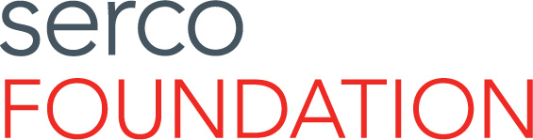
The Serco Foundation is a charitable trust, working internationally,
to enhance public service outcomes for vulnerable citizens.

APPLICATION FOR SUPPORT

- Please complete this form and return to info@sercofoundation.com.
- For guidance on the kind of causes and initiatives which we are likely to support, please visit the Foundation website, where you can read case studies and detailed criteria. We are particularly interested in supporting

- A strong preference for applications that are explicitly sponsored by a Serco employee or group of employees (whilst applications without clear support from a Serco employee/employees will be considered by the Trustees, preference is for those which do have this support).

- In addition to requesting financial support, applications which also demonstrate a credible plan for Serco employees to provide in-kind support, such as volunteering or professional expertise;

- Charitable causes that somehow relate to Serco’s broad areas of operational expertise: Healthcare, Transport, Defence, Prison Management, Immigration Services, Skills & Training, and Waste Collection & Recycling.

- Charitable causes that broadly operate in those parts of the globe where Serco delivers public services: North America, Europe, the United Kingdom, the Middle East, and Asia-Pacific;

- Applications where there is no conflict of interest. Specifically, the Serco Foundation cannot make grants where there is any possibility the monies could support the public services that the Serco Group Plc is contractually obliged to deliver on behalf of governments.

1: YOUR ORGANIZATION

Name of your organization

Please describe your organization. Are you a charity, social enterprise, academic or research organization, or other non-profit distributing organization? What do you do, and what are your objectives?

In which region(s) do you work?

Do you have a website? If so, please provide the address.

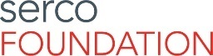 continued overleaf
2: YOUR PROPOSAL (CASE FOR SUPPORT)

Is this application sponsored by a Serco employee or group of employees? If so, please provide their name(s) and email addresses.
Name (or few-word summary) of your project/proposal

How would you describe the project/proposal for which you seek support?

What resources do you require (financial & in-kind support)?

Please describe the specific purpose(s) for which you are requesting these resources.

Do you propose to deliver any or more of a) to d) above? If so, which? Please describe in brief your overall objective.

How will your proposal, if funded, deliver impact for citizens and over what timeframe? Please provide an impact statement.

What is the timeframe of your proposal? How do you expect to achieve your objectives within this timeframe? What are your milestones?

How will you measure the success of your project?

Please outline the relevance of this proposal to your organization and your capacity to deliver it?

continued overleaf

3: CONTACT INFORMATION

Lead contact (name)

Position / title

Postal address

Email address

Telephone number

We look forward to receiving your application.

